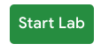
On the left is a panel populated with the temporary credentials that you'll need to use for this lab.
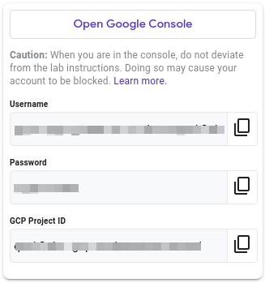
- Copy the username, then click Open Google Console. The lab spins up resources, and then opens another tab that shows the Choose an account page.
Tip: Open the tabs in separate windows, side by side.
Note: Using a new Incognito window (Chrome) or another browser for the Qwiklabs session is recommended. Alternatively, you can log out of all other Google / Gmail accounts before beginning the labs.
- On the Choose an account page, click Use another account. 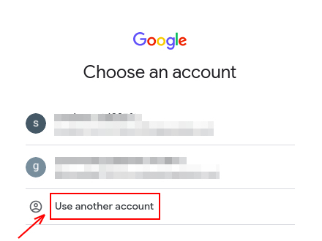
- The Sign in page opens. Paste the username that you copied from the Connection Details panel. Then copy and paste the password.
Important: You must use the credentials from the Connection Details panel. Please do not use your Qwiklabs credentials. If you have your own GCP account, do not use it for this lab in order to avoid incurring charges.
- Click through the subsequent pages:
- Accept the terms and conditions.
- Do not add recovery options or two-factor authentication, since this is a temporary account.
- Do not sign up for free trials.
After a few moments, the GCP console opens in this tab.

What you need
To complete this lab, you need:
- Access to a standard internet browser (Chrome browser recommended).
- Time to complete the lab.
Note: If you already have your own personal Google Cloud account or project, do not use it for this lab.

Create a VM instance from the Cloud Console
In this section, you'll learn how to create new, predefined machine types with Google Compute Engine from the Cloud Console.
In the GCP Console, on the top left of the screen, select Navigation menu > Compute Engine > VM instances:
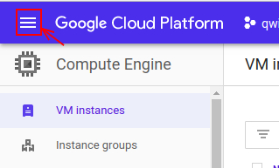
This may take a moment to initialize for the first time.
To create a new instance, click Create.
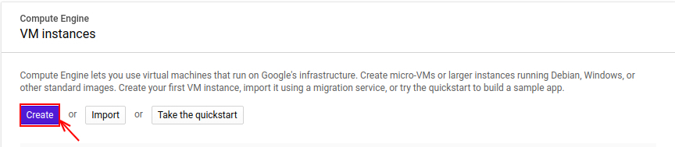
There are lots of parameters you can configure when creating a new instance. Use the following for this lab:
Field | Value | Additional Information
Name | vm1 | Name for the VM instance
Region | us-east1 | Learn more about regions in Regions & Zones documentation.
Zone | us-east1-b | Learn more about regions in Regions & Zones documentation.
Machine Type | n1-standard-1 | Note: A new project has a default resource quota, which may limit the number of CPU cores. You can request more when you work on projects outside of this lab.
Boot Disk | Ubuntu 18.04 LTS | Click on the change button, click on the OS images section then select Ubuntu 18.04 LTS. Learn more about boot disk check out this link.
Boot disk type | standard persistent disk | Learn more about standard persistent disk check out this link.
Firewall | allow HTTP and HTTPS traffic | Learn more about firewall check out this link.
Leave all the other configurations set to their defaults.
After entering the above parameters, click on the Create button to create your VM.
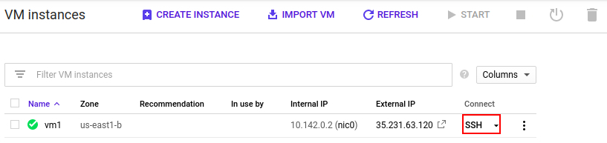
SSH into vm1 by clicking on the SSH button, as shown in the image above.

Git clone
Use Git to clone the repository by using the following command:
git clone https://www.github.com/google/it-cert-automation-practice.git
Output:
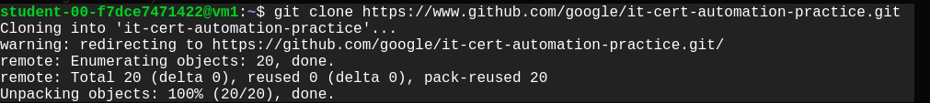

File operation
Once you have the repository successfully cloned, navigate to the Lab3/directory.
cd ~/it-cert-automation-practice/Course5/Lab3
To list the files in the working directory Lab3/ use the list command.
ls
Output:
In order to enable hello_cloud.py to run on boot, copy the file hello_cloud.py to the /usr/local/bin/ location.
sudo cp hello_cloud.py /usr/local/bin/
Also copy hello_cloud.service to the /etc/systemd/system/ location.
sudo cp hello_cloud.service /etc/systemd/system
Now, use the systemctl command to enable the service hello_cloud.
sudo systemctl enable hello_cloud.service

Restart the VM
After enabling the hello_cloud service, reboot the VM to ensure that the service is up. To reboot the VM instance vm1 go to the Compute Engine > VM instance and stop the VM instance vm1 by selecting the VM instance vm1 and clicking on the stop button at the top.
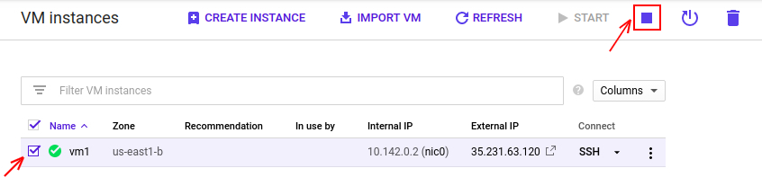
The start method restarts an instance in a TERMINATED state. To start the VM instance vm1, select it first by tick marking it, then click on the start button at the top. You can this in the image below.
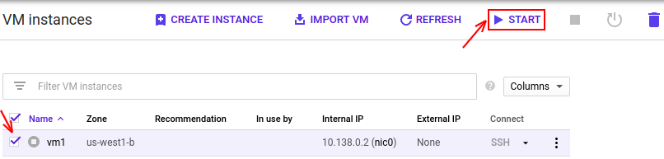
After restarting the VM instance vm1, visit the External IP link of the vm1 that's shown in the image below:
Output:
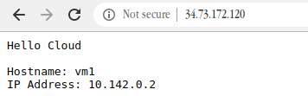

Create VMs using a template
You'll now create a template for vm1.
First, shut down the VM instance vm1 by going to the Compute Engine > VM instance, selecting the VM instance vm1, and clicking on the stop button at the top.
Now, create an image named vm-image based on the vm1 disk by following the steps below:
In the GCP Console, on the top left of the screen, select Navigation menu > Compute Engine > Images:
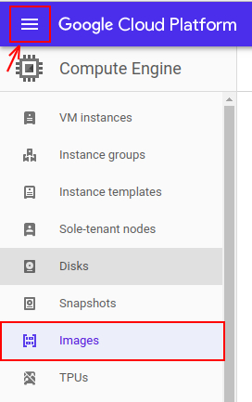
Click on the CREATE IMAGE button below.
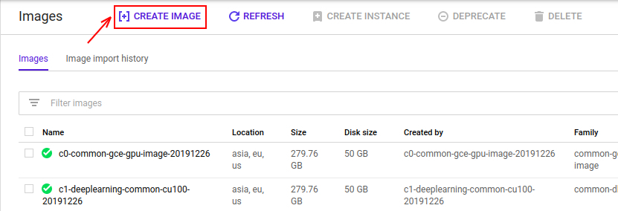
Then, create an image based on the vm1's disk, using the following parameters:
Field | Value
Name | vm-image
Source | Disk
Source Disk | vm1
Leave all of the other values set to their default settings. Click on the create button to create your image.
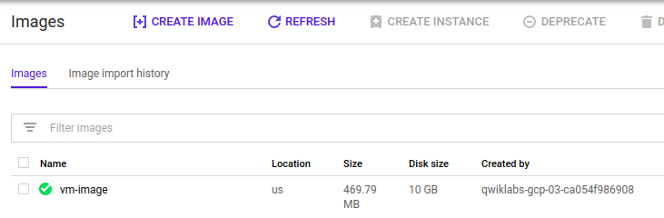
Now, create an instance template using vm-image for the boot disk you just created.
To create a instance template, follow the instructions below:
In the GCP Console, on the top left of the screen, select Navigation menu > Compute Engine > Instance templates:
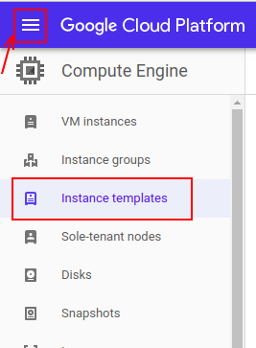
Now, click on Create instance template to create a new template.
There are lots of parameters that you can configure when creating a new instance. Use the following for this lab:
Field | Value | Additional information
Name | vm1-template | Name for the VM instance template
Machine Type | n1-standard-1 | Note: A new project has a default resource quota, which may limit the number of CPU cores. You can request more when you work on projects outside of this lab.
Boot Disk | vm-image | Click on the change button, click on the custom images section. Now, select vm-image by selecting the project you are working on.
Boot disk type | standard persistent disk | Learn more about standard persistent disk check out this link.
Firewall | allow HTTP and HTTPS traffic | Learn more about firewall check out this link.
Leave the rest of the values set to their default settings. Click on the create button to create the instance template vm1-template.
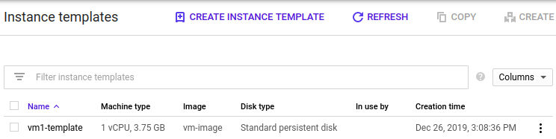
Click Check my progress to verify the objective.
Now, you'll create new VM instances with the template named vm1-template from your local computer using gcloud command-line interface. To do this, return back to the command line interface on your local computer, and enter the following command:
gcloud compute instances create --zone us-west1-b --source-instance-template vm1-template vm2 vm3 vm4 vm5 vm6 vm7 vm8
Wait for the command to finish. Once it's done, you can view the instances through the Console or by using the following gcloud command on your local terminal:
gcloud compute instances list
Now, open the external links for vm2 and vm8 to check if all the configuration set up properly as vm1.
Output:
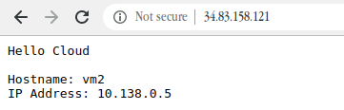
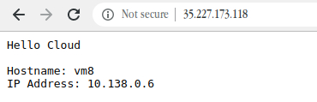
Click Check my progress to verify the objective.

